Justin Wells

Professor Barberopoulou

GIS101: Intro to GIS

9 May 2024

**Identifying Potential Host Sites for Expansion in Major League Baseball**

**Introduction**

Sports fans, like me, and stakeholders alike are very interested in Major League Baseball's (MLB) expansion, which has sparked discussions about potential development areas and the future of America's favorite pastime. In addition to broadening the league's appeal, adding additional clubs has a significant impact on the local economy and culture as well as the host city. It's an endeavor that goes beyond simple athletic events and becomes a driving force behind job creation, economic growth, and community pride. It is critical to thoroughly assess and choose appropriate host towns that can accommodate the needs and goals of a professional baseball club as the MLB looks at opportunities for growth and the possible relocation of current teams. These cities become magnets of activity, centers of local identity, and sources of city and state pride in addition to being venues for sports.

I have gone out on an extensive search to identify possible cities or towns that have what it takes to either host an expansion team or provide housing for a team that is having difficulties in its current location. Through an exploration of the complex interactions between infrastructure, economics, sports culture, and demography, my goal was to uncover underutilized opportunities and markets that are just waiting for a baseball craze to take hold. Throughout this project, I have delivered practical insights that enable MLB decision-makers to make well-informed decisions on relocation and expansion plans utilizing thorough research and geographical analysis. My consistent plan has been to seize opportunities, reduce risks, and clear the path for the league and its connected communities to develop and flourish sustainably by utilizing data-driven techniques.

**Data and Data Sources**

A majority of my data is centered on city infrastructure and transit, economic background, population base, and surrounding sports and entertainment culture.

ArcGIS Online: Transit and Infrastructure Data

ArcGIS Online has served as a central repository for transit and infrastructural data crucial to my research. This platform provided comprehensive information on transportation networks, infrastructure layouts, and other spatial data relevant to each of the cities under investigation. By leveraging ArcGIS Online, I gained valuable insights into the existing transit systems and infrastructure complexities within the study areas.

Homeland Infrastructure Foundation - Level Data (HIFLD): Sports Venues Information

The Homeland Infrastructure Foundation - Level Data (HIFLD) played a pivotal role in identifying and analyzing existing sports venues across the United States. This data source provided detailed information on venue capacity, locations, and levels of fan engagement, enabling a thorough assessment of the sports infrastructure landscape about potential expansion team locations.

Census.gov: Economic and Population Data

For economic analysis, Census.gov emerged as a vital resource, supplying comprehensive economic and population data essential to the project's objectives. Specifically, Census.gov provided detailed insights into household income data, with a focus on median household income for strategic planning purposes, and population variables, with an emphasis on people in the population who are considered dependent.

Economic Data Analysis

Using the economic data obtained, particularly focusing on median household income, I conducted detailed analyses to identify areas in need of economic upliftment within the cities under consideration. This analysis aimed to pinpoint regions where the introduction of an expansion team could contribute positively to economic growth and development. Additionally, the data helped in assessing the economic suitability of hosting expansion teams based on county-level economic indicators.

Population Data Analysis

The population data sourced, particularly regarding the percentages of dependents in different areas, played a crucial role in understanding demographic trends and dependencies within the study regions. Analyzing the percentage of dependents outside the typical working age range (18-65 years old) allowed for the identification of areas with lower dependency ratios, which could be favorable for hosting expansion teams and supporting sustainable growth initiatives.

This data was instrumental in identifying areas requiring economic stimulation and assessing the economic viability of hosting expansion teams in specific counties and what areas could benefit from the potential for a new fan base to increase revenue and reach for the league.

It also helped me to answer my specific spatial/research question: *Which cities or towns possess the optimal combination of population demographics, economic stability, existing sports culture, and infrastructure to support the successful establishment of an MLB expansion team?* The table below outlines in detail all of the data I used and the sources for each of the datasets needed for the project.

|  |  |  |  |
| --- | --- | --- | --- |
| File Name | Source | Type of Data | Description |
| Major Sports Venues | (Homeland Infrastructure Foundation - Level Data (HIFLD)) | Point Data  (Vector) | locations of major sports venues and information about each facility |
| ACS Median Household Income | Census.gov | Polygon Data  (Vector) | median household income by race and by age of householder shown by tract, county, and state boundaries |
| ACS Population Variables | Census.gov | Polygon Data  (Vector) | most current release of data about total population count by sex and age group shown by tract, county, and state boundaries |
| Nashville Transit (WeGo) | ArcGIS Online | Point Data  Line Data  (Vector) | rail lines, stations, and routes for Nashville transit |
| Charlotte Transit | ArcGIS Online | Line Data  Point Data  (Vector) | Charlotte Area Transit System (CATS) rail stations, routes and bus stops and routes |
| UTA Transit Routes | ArcGIS Online | Point Data  Line Data  (Vector) | UTA Commuter Rail, Light Rail, Local Bus routes and Commuter Rail & Light Rail Stations. |
| Portland Oregon Transit | ArcGIS Online | Point Data  Line Data  Polygon Data  (Vector) | Bus stops, buslines, park and ride lots, transit centers for Portland, OR as well as census tract data for 20 districts |
| Sacramento Transit | ArcGIS Online | Point Data  Line Data  (Vector) | Sacramento Regional Transit (SacRT) and Bus (Etrans) stops and routes in Sacramento area |
| Sacramento Region Bus Stops | ArcGIS Online | Point Data  (Vector) | Locations of bus stops in Sacramento, CA area |

**Methods**

Pinpointing Potential Cities for Expansion Teams

To identify five potential cities suitable for hosting an expansion team, I employed a multi-step approach. Initially, I conducted extensive online research to gain a broad understanding of which cities would likely meet the criteria. This research phase involved analyzing various factors such as population size, economic indicators, existing sports infrastructure, and cultural aspects related to sports enthusiasm.

After compiling a preliminary list of approximately 10-15 cities, I utilized spatial data analysis, focusing primarily on economic and population data, to further narrow down the selection to five cities worthy of more in-depth examination. Key questions guided this process, including whether these cities already hosted teams from different leagues, the presence of tourist attractions, and the overall suitability for additional sports facilities like stadiums and housing developments from both an economic and spatial perspective.

The final selection of potential cities for expansion teams comprised Nashville, TN, Charlotte, NC, Salt Lake City, UT, Portland, OR, and Sacramento, CA, chosen based on their alignment with the previously mentioned criteria and their potential for fostering a thriving baseball culture.

Utilizing Select by Locations and Select by Attributes

To refine the economic and population data for the five selected cities and their surrounding areas, I employed the Select by Locations and Select by Attributes functionalities within ArcGIS. These tools allowed me to focus specifically on the data relevant to each city, ensuring a more detailed and accurate analysis tailored to the expansion team's potential impact and feasibility in those regions.

Spatial Join for Transit and Infrastructure Analysis

A crucial aspect of my ArcGIS project involves conducting a spatial join of all transit and infrastructure data gathered for each of the five cities. This process aims to create a comprehensive visual representation of travel patterns, accessibility, and existing infrastructure within each respective region. By integrating this data, I will gain valuable insights into the transportation networks, urban development, and overall connectivity that play a vital role in determining the viability of establishing an expansion team in these locations.

**Discussion and Findings**

Income

The first thing I looked at was the economic outlook of potential cities which is crucial in the expansion process. Choosing a city with a strong economic outlook is important to ensure that the team is set up for success and long-term viability. Being located in a strong market can positively impact potential revenue streams such as ticket sales, merchandise sales, and corporate sponsorships.

From a baseball standpoint, having a strong market also can help teams attract and retain talent. Like most people, players often seek teams in good communities that provide them with a good area for families as well as opportunities to seek out endorsement deals and investments.

These first two maps look at median household income which is essentially the income level that falls exactly in the middle when all household incomes are ranked from lowest to highest to pretty much find the average income a household makes in that area. We want to find good candidates that have mostly darker tracts because this means they have higher median household incomes in comparison to the other cities and the counties that they are in

While this more detailed look at each city area shown in the first map can be helpful, taking a step back and looking at the counties surrounding the major cities is just as important. This is because a fan base and economy doesn’t only consist of the people who are going to be living right next to the stadium but rather those in the general surrounding area throughout the state.

When looking at the second set of maps we can get some insight into income levels in surrounding counties. When analyzing these maps, I looked for not only want to find higher economic value for sustainability for a potential expansion team but also areas with counties that have lower income levels because they will likely benefit from having a new expansion team because of increases in jobs, more tourism possibilities and opportunities for local businesses to thrive.

For example, in Sacramento, the surrounding counties tend to have higher household incomes, most likely because of the proximity to other cities, as well as a number of other factors. On the coastline, where all of these stadiums are, the median household income of those counties is much higher. This is a positive in the sense that the economy is more than stable enough to handle an expansion team, but it also means that it isn’t necessarily in need of one, and another city might be better suited to see a major boost economically from adding a new team.

Nashville’s surrounding counties tend to have lower household incomes which makes it a good spot to establish a new expansion team in order to bring in more revenue and boost the surrounding economy overall. From an economic standpoint, there is a lot of room for opportunity and growth which can make the city more favorable for the addition of a new ball club.

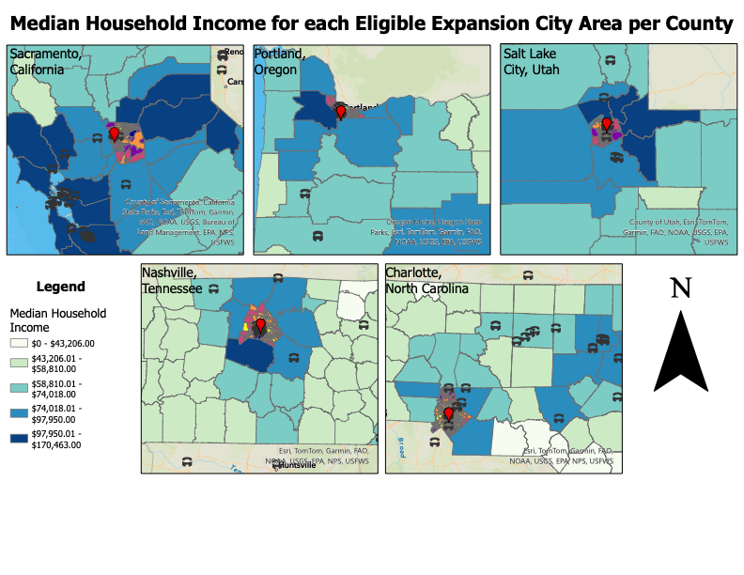

Population

Having a solid population base is crucial for the success of any sports team, especially for new expansion teams entering competitive leagues like MLB. A key factor in assessing the potential of a population base is the percentage of dependents within specific areas, notably focusing on individuals aged 18 to 65 years old. Areas with a lower percentage of dependents in this age range are particularly advantageous for several reasons.

Firstly, a lower percentage of dependents signifies a larger proportion of individuals in the prime working and spending age group. This demographic is more likely to have disposable income available for entertainment activities like attending baseball games, purchasing merchandise, and supporting the team through various revenue-generating avenues. As a result, areas with a higher concentration of working-age adults can contribute significantly to the financial success of an expansion team by creating a strong and financially supportive fan base.

Secondly, regions with a lower percentage of dependents often indicate a more stable and economically active population. These areas are typically characterized by higher levels of employment, higher household incomes, and greater overall economic vitality. Such economic stability translates into increased purchasing power among residents, translating into higher ticket sales, sponsorships, and merchandise purchases for the team.

A suitable population base with a higher number of independents (18 to 65-year-olds) tends to be more engaged and supportive of local sports teams. These individuals are more likely to actively participate in fan activities, attend games regularly, and contribute to the overall community enthusiasm for the team. This heightened level of support not only boosts revenue streams but also creates a vibrant and passionate fan culture that can enhance the team's brand image and long-term sustainability, which benefits Major League Baseball in a significant way.

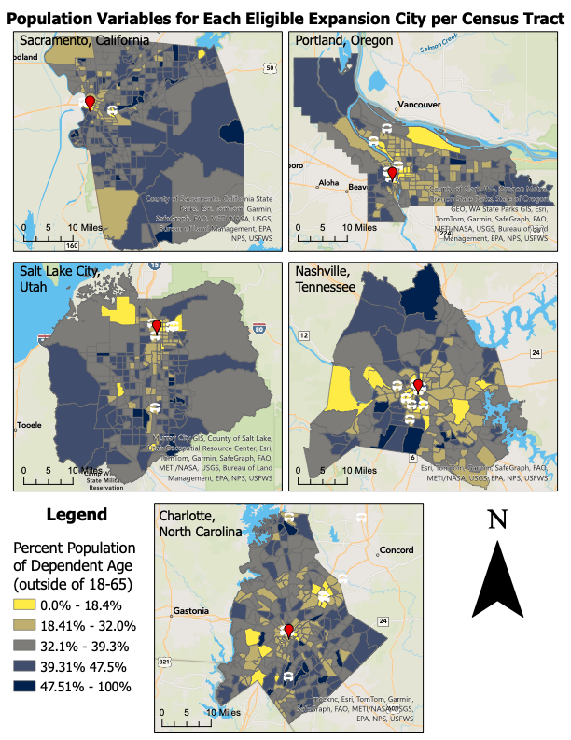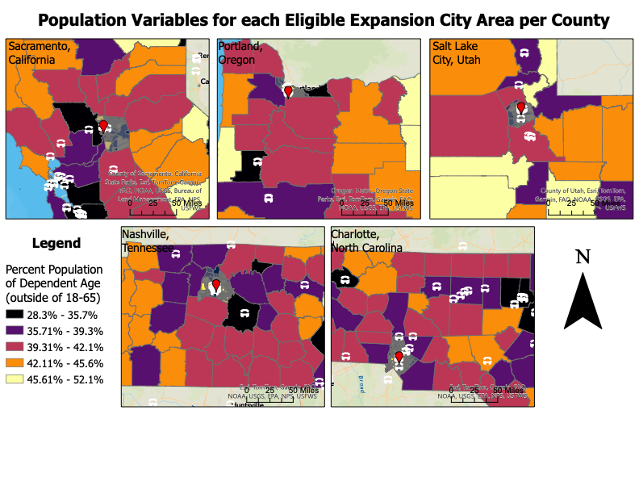

Infrastructure/Transit

Infrastructure and transportation are critical considerations when evaluating potential cities for hosting an MLB expansion team. The presence of a well-developed transportation network is paramount in ensuring the success and sustainability of a new stadium.

Accessible transportation options not only enhance the fan experience by making it easier for supporters to reach the stadium but also contribute significantly to building a dedicated and engaged fan base. When fans can easily access the stadium via various transportation modes such as public transit, highways, and parking facilities, they are more likely to attend games regularly, fostering loyalty and enthusiasm for the team.

A robust transportation system is not just beneficial for fans; it also plays a vital role in the overall business operations of the team. For instance, it serves as a compelling incentive for attracting top players, corporate sponsors, and community support. Players are more inclined to join teams located in areas with excellent transportation infrastructure, as it enhances their accessibility to training facilities and other amenities. Corporate sponsors also find value in partnering with teams situated in easily accessible locations, as it ensures maximum exposure and reach for their brand.

A well-connected transportation system strengthens relationships with the broader community, including local businesses, residents, and government entities. This enhanced connectivity fosters a sense of belonging and support, leading to increased attendance, revenue opportunities, and overall organizational success. Essentially, prioritizing transportation and infrastructure when selecting a city for an MLB expansion team not only improves the fan experience but also creates a foundation for long-term growth, profitability, and community engagement.

**Conclusions**

In my opinion, Nashville, TN, and Salt Lake City, UT emerge as standout candidates for hosting an expansion team in Major League Baseball due to a combination of economic, population, and transit/infrastructure advantages. From an economic standpoint, both cities showcase promising median household income data, indicating strong economic stability and potential for generating substantial revenue for the team. Additionally, the surrounding counties of Nashville exhibit lower household incomes, making it an ideal spot to establish a new team and stimulate the local economy. On the other hand, Salt Lake City benefits from a diverse economic base and a thriving business environment, providing ample opportunities for corporate sponsorships and financial support.

In terms of population, Nashville and Salt Lake City boast population bases with lower percentages of dependents, meaning they have a particularly high percentage in the prime working age group of 18-65 years old. This demographic composition suggests a financially active and supportive fan base that is likely to contribute significantly to ticket sales, merchandise purchases, and overall team support. Both cities have vibrant and engaged communities passionate about sports, further enhancing the potential for building a loyal and enthusiastic fan following.

From a transit and infrastructure standpoint, Nashville and Salt Lake City offer well-developed transportation networks and infrastructure, ensuring easy accessibility to stadiums and enhancing the overall fan experience. These cities' robust and detailed transit systems serve as incentives for attracting players, corporate sponsors, and fans, contributing to the team's success and sustainability, and allowing access from fans in the area close to the city and far out.

Overall, these two major cities, emerge as top contenders for hosting an expansion team in Major League Baseball, combining economic strength, favorable demographics, and excellent transit/infrastructure facilities to create an ideal environment for a successful and thriving baseball franchise.